Placement Record
HOME \

Stream wise Placement Statistics

Couses | B. Tech |  |  | B. Tech & MCA
Batch | 2007 | 2008 | 2009 | 2010 | 2011 | 2012 | 2013 | 2014 | 2015
CSE | 57 | 58 | 57 | 89 | 87 | 77 | 63 | 92 | 95
ECE | 59 | 62 | 58 | 89 | 85 | 81 | 62 | 72 | 89
EIE | 57 | 58 | 53 | 64 | 58 | 53 | 40 | 42 | 41
EE | 59 | 55 | 52 | 68 | 57 | 57 | 41 | 51 | 42
ME | 58 | 58 | 64 | 55 | 57 | 49 | 45 | 38 | 39
IT |  |  |  |  | 60 | 58 | 42 | 39 | 49
MCA |  |  |  | 51 | 47 | 41 | 27 | 35 | 40
Total Placed | 290 | 291 | 284 | 416 | 451 | 416 | 302 | 369 | 395
Total no of Students | 308 | 313 | 308 | 444 | 483 | 497 | 493 | 475 | 490

Organization wise Placement Statistics

All reputed organizations from the core industry as well IT based sector, some of which are MNCs, come to the College for campus recruitment. To achieve its goal, the Training and Placement Cell works towards recognizing the core competencies of students. FIEM provides for securing multiple placement opportunities for its students by providing varied student support activity like technical paper presentation, technical talks, seminars and conducting soft-skill and supplementary technical classes.
- 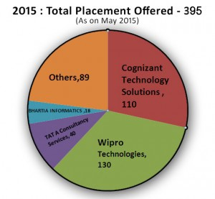
- 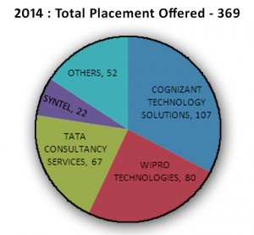
- 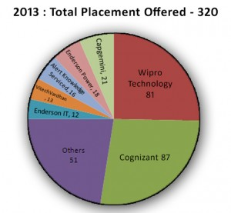
- 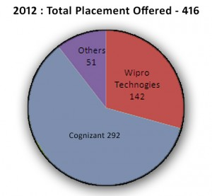

OUR COURSES
- B.Tech in Computer Science & Engineering
- B.Tech in Electrical Engineering
- B.Tech in Electronics & Communication Engineering
- B.Tech in Applied Electronics & Instrumentation Engineering
- B.Tech in Information Technology
- B.Tech in Mechanical Engineering
- Bachelor in Business Administration (BBA)
- Master in Business Administration
- Bachelor in Computer Application
- Master in Computer Application

Today, Team Future’s excellence spans across education, publishing and healthcare verticals with a group net worth of over 100 crores. The Team continues to strive towards using the best resources available to achieve inclusive learning and innovations.

CONTACT US

Future Institute of Engineering & Management
Address: Sonarpur Station Road, Kolkata - 700150Email: info@teamfuture.in
Telephone: +91 9830088984, 9836107275
Privacy Policy
TOP
© Team Future, 2015-2016

